June Field Trip - Himalaya Mine Tourmaline
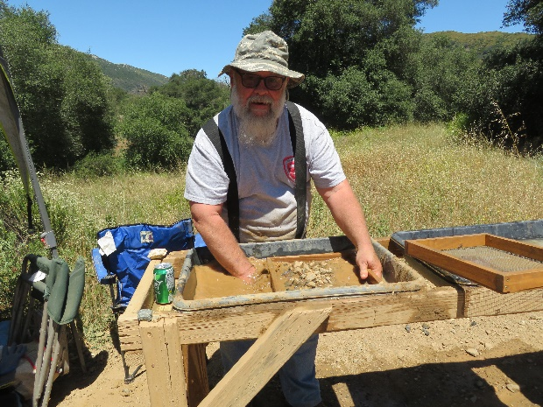
We have 25 Searchers and friends attend the field trip. I think everyone enjoyed the day.
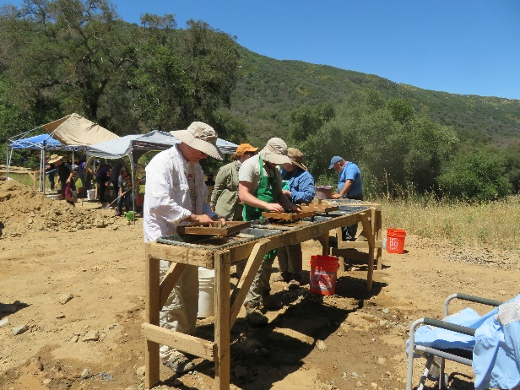

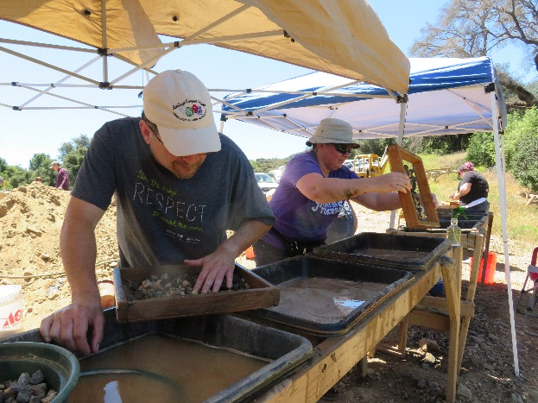
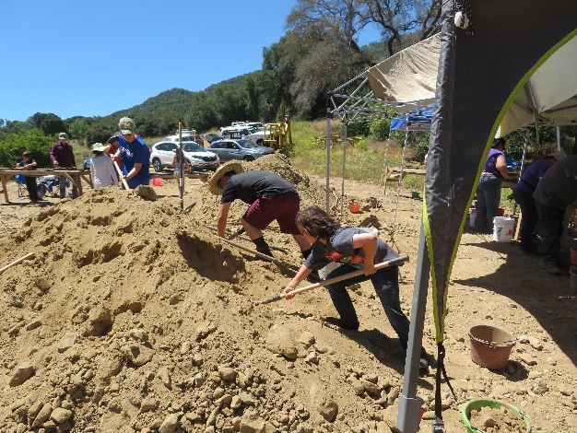

July & August – No field trips scheduled due to the summer heat.

